CENWP-OD 17 December 2009

MEMORANDUM FOR THE RECORD

Subject: Finall minutes for the 08 December 2009 FPOM meeting.

The meeting was held in the St. Helens Room at NOAA’s Portland Office. In attendance:
Last | First | Agency | Office/Mobile | Email
Baus | Doug | USACE-RCC | 503-808-3995 | Douglas.M.Baus@usace.army.mil
Bettin | Scott | BPA | 503-230-4573 | swbettin@bpa.gov
Benner | David | FPC | 503-230-7564 | dbenner@fpc.org
Clugston | David | USACE-NWP | 503-808-4751 | David.a.clugston@usace.army.mil
Dykstra | Tim | USACE-NWW | 509-527-7125 | Timothy.A.Dykstra@usace.army.mil
Fredricks | Gary | NOAA | 503-231-6855 | Gary.fredricks@noaa.gov
Hausmann | Ben | USACE-BON | 541-374-4598 | Ben.j.hausmann@usace.army.mil
Hevlin | Bill | NOAA | 503-230-5415 | Bill.hevlin@noaa.gov
Kruger | Rick | ODFW | 971-673-6012 | Rick.kruger@coho2.dfw.state.or.us
Lorz | Tom | CRITFC | 503-238-3574 | lort@critfc.org
Mackey | Tammy | USACE-NWP | 541-374-4552 | Tammy.m.mackey@usace.army.mil
Moody | Greg | USACE-NWW | 509-527-7124 | Gregory.p.moody@usace.army.mil
Richards | Steven | WDFW | 509-545-2050 | richaspr@dfw.wa.gov
Wills | David | USFWS | 360-604-2500 | David_wills@fws.gov
Hausmann, Hevlin, Richards called in.

- Finalized results from this meeting.
  - November FPOM minutes approved. Hevlin would like to see a summary of the minutes. He feels they are getting rather long and take too much paper to print out. Klatte reported that Mackey will be given additional tasks in providing summaries of the minutes in addition to the full minutes. ACTION: Hevlin will send an example of the SCT meeting summaries. Fredricks commented that he finds the digital recordings very helpful and appreciates them being posted to the web.
  - FPOM would like mortality reports on all native species.
  - FPOM recommends that the BON TDG at Cascades Island issue be moved to FFDRWG.
  - FPOM decided the BON TIES need to be installed by 01 March 2010 and pulled by early summer.
  - BON JMF upper switchgate. FPOM would like to have the Project observe how well the new neoprene seal works this year. At this time, routine maintenance is the only fix available.
  - FPOM was pleased with the results Dykstra has brought about with regards to the LWG fish trap.

- The following documents were provided or discussed.
  - Agenda, Fish Passage O&M Coordination Team.
  - Zinc calculations. Page 9
  - Lamprey Task Group list of mods for each NWP Project. Pages 10-11
  - NOAA’s Delayed Installation of ESBS’s at McNary Dam in 2010. Pages 12-18
  - TDA avian array. Pages 19
  - FPP change forms. Pages 20-26
  - Fisheries calendar. Pages 27-29
  - LWG kelt infrastructure photos. Pages 30-32

- Action Items
  - [Nov 09] LGS and LWG fish transport. ACTION: Dykstra to see if study continues in 2010. STATUS: The study is going to continue in 2010 so any changes can not affect LWG. Dykstra also said that when there are low numbers of fish, there will not be a truck that only stops at LGS, but if there is a truck leaving LWG, it will stop in at LGS. Bettin asked when the study ends. Dykstra said the study ends each season at the end of October and the study will conclude in 2010.
  - [Nov 09] Galvanized grates. ACTION: Cordie to review Fredricks’ proposed formula for zinc ratio. STATUS: Cordie sent an excel document with the formula. The engineers are still working on the calculations for finding a standard number. They need a little more time.
  - [Jun 09] BON spillway repairs. ACTION: Lee will provide updates to FPOM. STATUS: The memo is being finalized. It is addressed to Jim Hinds, Portland District Dam Safety Program Manager.
  - [Oct 09] MCN and IHR lamprey velocity tests. ACTION: Fryer will send a draft report to Dykstra. STATUS: Report sent with the agenda and will be available on the FPOM website.
  - [Nov 09] BON VOB roof replacement. ACTION: Sawka will get answers to FPOM’s questions and email those to Mackey. STATUS: This project is no longer funded. Fredricks asked why. Klatte responded that the ARRA funding has been cut significantly over the past few weeks.
  - [Nov 09] FPP change forms. ACTION: NWW and RCC will submit additional change forms to Mackey for inclusion in the November FPOM minutes. STATUS: included with the FPP change forms.
  - [Nov 09] BON Fish unit trash rake. ACTION: Bon will schedule a test date and let the Region know. District Engineers can show up or they can view a video. STATUS: Test date is 8 December 2009. Hausmann reported that the VBSs collected a lot of debris overnight, so the test will need to be postponed.
  - [Nov 09] Dead fish reporting. ACTION: Klatte will send out a reminder to all projects that fish mortalities will be reported as per the FPP section 3.3.3 for NWP projects. Dykstra will have NWW projects report mortalities in the weekly reports. STATUS: Klatte sent a message to NWP bios on 24 November. Cordie asked about reporting non-native species such as shad. FPOM would like native species reported on.
  - [Nov 09] NWP lamprey mods. ACTION: FPOM will review the list and provide feedback at the December meeting. To be discussed under Lamprey mods.
  - [Nov 09] FPP change form 10MCN003- 2.3.1.2.b.1 Delay of ESBS installation. ACTION: Dykstra will re-write the change form for the December FPOM meeting. Discussed under MCN ESBS installation.
  - [Dec 09] FPOM meeting minutes. ACTION: Hevlin will send an example of the SCT meeting summaries. STATUS: Sent on 10 December.
  - [Dec 09] MCN and IHR lamprey velocity tests. ACTION: Mackey will make sure FPOM gets a copy of the report. STATUS: Mackey sent the report on 11 December. The report will be on the FPOM website. http://www.nwd-wc.usace.army.mil/tmt/documents/FPOM/2009/
  - [Dec 09] BON TDG at Cascades Island. ACTION: Klatte will talk to K. Tackley to figure out what she can do. He will also talk with Schlenker about getting involved.
  - [Dec 09] BON B2CC opening date. ACTION: Fredricks will draft the B2CC change form.
  - [Dec 09] LGS NPE-3 and NSE-3 Bulkheads. ACTION: Dykstra said they would bring this back to FPOM.
  - [Dec 09] LGS NSE-1 Weir operator damage. ACTION: Dykstra said NWW will do more analysis to determine where the weir may be dogged off. He will bring this back to FPOM in January.
  - [Dec 09] Lamprey mods. ACTION: Mackey will get further clarification on the corner rounding
  - [Dec 09] LWG New Kelt Infrastructure. ACTION: Dykstra will email the photos to Mackey for inclusion in the minutes.
  - [Dec 09] MCN ESBS installation. ACTION: Lorz will draft a memo detailing the benefits to lamprey, as best he can with the information available.
  - [Dec 09] MCN ESBS installation. ACTION: Fredricks will find out what level of mortality will trigger re-consultation

- Updates.
  - BON 07 Dec BI dewatering. FV4-3 has a broken shaft so no water could be provided at FG3-18 to flush sturgeon out. The Project cracked the BI exit overnight to help encourage the sturgeon to move downstream. In addition, there was a metal plate that was knocked loose in the junction pool. Due to the open holes, Fisheries will need to get under the junction pool to salvage any fish that may have gotten underneath.
  - BON PH1 grizzlie drain modifications. Hausmann reported that there is still no funding source. Lorz asked if there was a design but no money. Wills asked if it is shovel ready. Klatte said he will keep it in the queue of projects.
  - BON TDG at Cascades Island. Klatte reported that Kathryn Tackley has not done further work after the initial 2005 investigation. Lorz asked if we know the range of forebay elevations that cause the problem. Hevlin suggested she put together a couple of concepts for fixing the problem. Fredricks expressed concern that Steve Schlenker doesn’t appear to be involved. Benner asked how much data she collected; Klatte said she has about three months worth. ACTION: Klatte will talk to K. Tackley to figure out what she can do. He will also talk with Schlenker about getting involved. Bettin suggested a one pager to FFDRWG. FPOM recommends that this issue be moved to FFDRWG. Mackey asked if this was going to apply only to CI or to B-Branch and FV1-1 as well. Wills suggested that FFDRWG start with CI and if they can come up with a fix then it can be applied to the other areas.
  - BON UMT Smith-Root array installation. Lorz asked if they are monitoring right now. Bettin said they will when they procure the correct DIDSON. Lorz mentioned that CRITFC may be inviting Smith-Root to discuss their concerns. Klatte mentioned that there was a two inch gap that had to be filled with plexi-glass. The gap was at the upstream end.
  - BON TIE Crane. Update on the testing of the boom. Auxiliary hoist has been tested. The final load test should occur on 08 December. No estimated return to service date. Klatte suggested FPOM consider thinking about whether or not we install the TIES in 2010. Fredricks said put them in since we have the data with the TIES out. He also suggested we do a treatment test with TIES in and TIES out…his comment was in jest, though he is serious about putting TIES in this year since there will be fish to get information on. FPOM says put the TIES in by 01 March 2010 and pull them by early summer. Fredricks said he doesn’t expect them to have a lot of affect on the B2CC, but they do have an affect on the units they are over. There may be flexibility on the install date; the Project will need to submit a change form.
    - Fredricks asked where the task group left the issue. The task group left it with the recommendation for a test with them in. Bettin suggested putting them in Spring 2010 due to the failing condition of the TIES. The test will be Spring with Unit 11 OOS. Klatte asked if the TIES could remain in; Bettin suggested that they should be removed since they don’t get as damaged on land. If the installation date needs to be changed, a change form should be submitted.
    - Bettin asked if there was a request to open the B2CC in March. Fredricks said they want the B2CC open as per the criteria he put together in the memo from last year. FPOM discussed the differences of opinion as to whether or not the B2CC is a fish passage facility or spill. Bettin suggested a FPP change form may be useful in establishing how the B2CC will be operated. Lorz asked which would be a better tactic- stating the B2CC is a fish passage system or using the kelt trigger. ACTION: Fredricks will draft the B2CC change form.
  - BON JMF upper switchgate seal modifications. Hausmann said he was informed that the new air bladder seal at the JDA SMF switchgate leaks just as much as the old one. Until that issue has been corrected, BON will not be installing a new seal. Lorz resurrected the idea of a knife gate for BON. Fredricks says he is just a biologist not an engineer. NOAA Fisheries doesn’t have any engineering staff at this time. Hausmann asked where FPOM would like the Project to go from here. Fredricks said the design of the gates needs to be revisited. He just wants it fixed and expects the Project to figure out the fix. New neoprene will be installed this winter. FPOM would like to have the Project observe how well that replacement works this year. It may be that the neoprene will be replaced each year.
  - TDA-E AWS back-up (language added to the minutes since Mackey didn’t have the information at the meeting) Cordie sent word that the project has been put on hold as it did not make the CRFM priority list for FY2010. HDC has suggested that the fish units are over due for an outage and if a generator winding is blown, it’s a minimum of an 18-month outage.
  - LGS NPE-3 and NSE-3 Bulkheads. Moody reported that the bulkheads are in need of replacement or repair. NSE-3 lost the upper third due to the vibration caused by spill. NPE-3 is being looked at today. An Army dive team will be on-site near the end of February to try to remove the bulkheads. If that doesn’t work, the temporary fix is to put metal plates up. The plates will be installed on the spillway side. This will result in sharp edges. FPOM doesn’t like that idea. Lorz asked if they could do a cast in place and just be done with the entrance. If the entrance is filled in, that removes the need for maintenance, which is a benefit. Hevlin would like more discussion since that area needs to be very smooth. He would like to see some quality engineering and some reports from Sean Mulligan and other NWW engineers. Wills clarified that the discussion is currently about whether or not a permanent fix could be done or if it needs to be removable. Hevlin indicated he doesn’t think there would be a problem with a permanent fix but he would like to talk to others who have been around longer. ACTION: Dykstra said they would bring this back to FPOM.
  - LGS NSE-1 Weir operator damage. The controls were shorted out. The weir was dropped to the sill. The operator was heavily damaged. It was moved out of place, shorted out and there is no off the shelf replacement available in the United States. Navy divers will be brought in to move the weir off the sill. The weir will be out of service for the entire season since repairs will take about a year. Fredricks asked if the weir could be lifted by a crane. Moody said they have no crane out there. The weir dropped about three weeks ago so NSE-2 has been closed to compensate. Fredricks suggested dogging NSE-1 at an operable head differential and always maintain head at NSE-2. ACTION: Dykstra said NWW will do more analysis to determine where the weir may be dogged off. He will bring this back to FPOM in January. Hevlin asked if the repairs would be by next March. He said there were studies of the velocities and if the weir was going to be modified, it will affect those velocities. He would like to see those researchers involved in the decision-making. Dykstra said that would happen.

- Lamprey mods. FPOM will provide feedback on the list of proposed modifications.
  - Cordie sent word that TDA is moving forward with TDA-E #3, #4 and #7 and TDA-N #3. In addition, they are getting a concrete cutter to grind a 2” radius on the 90° corners on the floor. ACTION: Mackey will get further clarification on the corner rounding. Wills asked for more clarification about the lamprey grating list. Mackey clarified that the lamprey mods is a list of items that could be done to improve lamprey passage. Easy stuff could be accommodated with winter O&M, other items may require special funding.

- LWG New Kelt Infrastructure. ACTION: Dykstra will email the photos to Mackey for inclusion in the minutes. Dykstra handed out photos of the new kelt upgrades to the LWG JFF. Last year kelts were collected in five-gallon buckets and carried downstairs in those buckets. That was not seen as an ideal handling plan so modifications were made. CRFM funds were used to purchase PVC pipe. Fish handlers can take kelts off the separator and place them in the kelt bin. From there the kelts travel down a gently sloping pipe (enough flow so they won’t swim up but not fast enough to shoot them through the pipe). The pipe will end at two kelt tanks, currently being constructed by University of Idaho. There is a concrete pad for the kelt tanks to sit on. The pipe is 10”. Everyone viewed this as an upgrade to the previous kelt collection method. This should be in operation by March 2010.
  - Hevlin commented that he was pleased the kelt facility is finally fixed. He said the researchers working on the kelt study had asked for improvements but those never happened. He said he thinks Dykstra is having a positive influence at the dam and he is happy to see that.

- LWG Fish trap. Dykstra sent the verbiage below.
  - Main point: The adult fish trap/holding tanks at Lower Granite now has an adequate water supply to run all six tanks down to at least elevation 734.2.
  - Background: Previously, even when the forebay elevation was 1.3 feet above MOP and higher, there was only enough water at the adult trap to operate 3 of the 6 holding tanks. Numerous efforts were conducted to identify the cause of this problem. Most recently, an ROV inspection failed to locate any obstruction in the 36-inch water supply pipe. After coordinating through FPOM and completing the construction of a new platform necessary for this work, the butterfly valve on the 18-inch waterline was replaced on Nov 17, 2009. Corresponding field tests occurred on Nov 18.
  - Preliminary results from the Nov 18 field test: For the first time since the addition of the holding tanks (March, 2007), the adult trap has enough water supply to run all six tanks. The new butterfly valve appears to have solved this problem. We noticed water runs through the new valve much quieter than it did through the old valve. Our preliminary finding is that the old butterfly valve was simply built with a more restrictive internal design and could not pass as much water as originally assumed. Also verified was our assumption that the old valve would slightly over stroke beyond full open by a few degrees.
  - Important note/clarification: The trap was designed to have enough water to operate all 6 adult holding tanks when the forebay elevation is 734.3 or above (MOP is 733). All 6 tanks were not designed to operate at MOP (based on constraints of a gravity-fed system). Consequently, we do not anticipate being able to operate all 6 tanks at MOP. When the trap is watered up during the 2010 fish passage season, we will learn precisely how many holding tanks can be operated when the forebay is at MOP.
  - Dykstra said he was very pleased with the installation of the valve. The installation went very well. Mike Halter had the authority to cancel the dewatering due to the number of fish, but that was unnecessary. The fish pumps were shut off the night before and there were only a few fish found in the ladder. Dykstra and Moody want to review the fish passage plan to make sure the guidance of shutting off the pumps is documented in there. After the installation of the new valve there was, for the first time ever, enough water to operate all six tanks and the spray bar. Forebay elevation was 2- 2.5’ above MOP. The system was not designed to operate all six tanks at MOP. Bettin asked if the valve was not opening all the way. Dykstra said he thought the issue was the design of the valve. The valve obstructed about 1/3 of the pipe. The new valve has a slimmer profile and a gauge indicating full open. Dykstra was glowing with pride as to how great the valve replacement went. He hopes this will put this issue to bed, the only outstanding issue is how many tanks can operate at MOP and how many are needed in the summer. FPOM says nice job. Hevlin commented that he is pleased with the improved condition of LWG. He asked what has changed and why are these issues now being addressed and corrected? Dykstra said the fish trap issue wasn’t on his radar until this last year and with some structural modifications, there was improved access to areas that weren’t accessible before so the valve could be replaced.

- MCN ESBS installation. Discuss 10MCN003 and Fredricks’ ESBS memo.
  - Dykstra said this is a mix of policy and technical and feels this is an FPOM decision and FPOM should make this decision.
  - Fredricks walked the group through the memo. He said it comes down to how many fish do you want to kill. From day one, salmonids will die if screens are not installed. He used two units a day for modeling the time for complete installation. If he took hatchery releases out, the mortality rates were cut in half. He feels the early season fish are wild fish, not hatchery fish, except for those recognizable hatchery releases. He talked with NOAA legal and was asked if he knew which ESUs they belonged to and are they listed. Fredricks said he didn’t know the ESUs but they are probably listed. Fredricks said he used the 10 year average since the year to year numbers have a lot of variability.
  - Lorz wasn’t convinced the 2% SARS is correct. He thinks it’s less than 2%.
  - Kruger commented that what was missing is the benefit. There was no answer to that because there isn’t a lot of information on lamprey survival through different passage routes.
  - Fredricks said if you assume a 1% return rate on chinook, some of these fish are headed up-river so they are pretty important.
  - Lorz said mitigation could be spill during the first two weeks. Fredricks said he agreed but you can’t spill just a little bit. We would need a good spill pattern and that would be a lot of water.
  - Dykstra interjected that there is a MCN transport study that is now out. In-river fish do better than bypass fish in the spring. Transport SARS are better than bypass SARS. There may be some support for spring transport of collected fish at MCN. He encourages everyone to review the report before it becomes final.
  - Klatte asked if there was a date that Fredricks was comfortable for installing screens. Fredricks said he isn’t comfortable with any of it but he is willing to listen to others and discuss the issue.
  - Lorz said there is no data. What are we going to do for lamprey? If lamprey get listed, that will change how everything operates and make life more difficult for everyone. Fredricks and others indicated lamprey need to be listed, given the numbers but they aren’t and salmon are.
  - Clugston said that one solution, if we had the money, would be to put improved screening on the units. Fredricks said there probably wouldn’t be money until the lamprey are listed.
  - Dykstra reviewed the change form. He put in there that the screens don’t go in before the first Monday in April and finish within two weeks. He would like to tweak the existing change form with dates or unit installation priority. He stated that we will make the best decision we can based on very little data. He would like to know what level of salmon mortality will require a re-consultation. Fredricks said he asked and didn’t get an answer.
    - Dykstra expressed concern about putting in 1-10 April since that allows zero flexibility. He said the minimal time he felt comfortable with was 1-14 April. That allows two units a day and no overtime.
  - Baus appreciated Fredricks’ comments but wanted to make sure everyone understands that the burden rests with USACE and the Action Agencies.
  - ACTION: Lorz will draft a memo detailing the benefits to lamprey, as best he can with the information available. ACTION: Fredricks will find out what level of mortality will trigger re-consultation.

- 2010 FPP change forms to be approved or rejected.
  - 10BON007 Table 3. Approved in December.
  - 10TDA004 Table 1 Approved in December.
  - 10JDA003 Table 3 Approved in December.
  - 10JDA004 2.5.1.2.d.2. Inadvertently left out of the agenda. Pending.
  - 10MCN003 2.3.1.2.b.1 Delay of ESBS installation. Pending
  - 10MCN0005 Trash rack cleaning frequency Approved in December, with changes
  - 10MCN006 updated Table MCN-1 Approved in December.
  - 10LMN004 updated Table LMN-1 Approved in December.
  - 10LGS001 2.3.1.2 SSW. Approved in December.
  - 10LGS002 updated Table LGC-1 Approved in December.
  - 10AppB001- section 3. Approved in November and December.
  - 10AppB002- 4.g.6 temperature gradient. Pending

- Potential 2010 FPP changes (change forms not yet drafted).
  - BON PH1 unit priority. This was a new issue brought up at the September meetings. With the removal of the ITS wall, the unit priority may change. Delete. No longer needed.
  - BON ITS operation details for section 2.4.1.1.e, 2.4.1.2.d, 2.5.1.1.n
  - BON B2CC opening date.
  - BON TIES installation date.

- Change forms approved or rejected.
  - 10BON001 2.5.2 tables. Approved in May.
  - 10BON002 Table BON 14. Approved in May.
  - 10BON003- 2.1.2 split flows - minimum flow requirements. Approved in November.
  - 10BON004- 5.8 high head unit ops. Approved in November.
  - 10BON005- removal of DSM1 language. Approved in November.
  - 10BON006- 4.2.2.2.e PH1 JBS language. Approved in November.
  - 10TDA001 TDA unit priority. Approved in June.
  - 10TDA002 2.5 shad. Approved in June.
  - 10TDA003- 5.7 fish unit loading during tail log installation. Approved in November.
  - 10JDA001 2.5 shad. Approved in June.
  - 10JDA002- 4.2.2.3 spillbay 2 closure. Approved in November.
  - 10MCN001
  - 10MCN002
  - 10MCN004 4.1 Turbine priority at elevated temperature. Approved in November.
  - 10IHR001 Unit Priority. Approved in August.
  - 10LMN001 Turbine Priority Clarification. Approved in May.
  - 10LMN002 4.3.1 Turbine headgate and cylinder removal. Approved in October.
  - 10LMN003
  - 10LWG001 Table LGR 12 summer spill. Approved in November.
  - 10AppB001- section 3. Approved in November.
  - 10AppJ001- BON high temp sampling. Approved in November.
  - 10AppK001- JDA high temp sampling. Approved in November.

- Other
  - TDA Avian array. Cordie emailed Mackey a photo of the potential array. TDA is moving forward with plans to install lines over TD tailrace 2010 as usual. They are working with spillwall tech lead Dave Hamernick for alternatives and best placement. Fewer wires than desired due to the limited time available on the bridge. Lorz asked if there would be increased hazing at TDA.
  - MCN outfall. Dykstra showed a diagram of the options and the estimated cost. FPOM reviewed the diagram and discussed some of the issues with the proposed options and the assumptions those options are based on.

- Upcoming FPOM Meetings
  - 13 January 2010- FPP meeting at NOAA. 0900 – 1600
  - 14 January 2010- FPOM meeting at NOAA. 0900 – 1400
  - 04 February 2010- FPOM meeting at NOAA. 0900 – 1400

- AFF meeting with TAC (1300-1600)

Support Bars
 | Height | 0.250 | inches
 | Thickness | 0.250 | inches
 | Spacing | 4.000 | inches
 | Surface Area | 36.000 | square inches
Total |  | 324.000 | In^2 surface / Ft^2 grating
 | East ladder calcs to date;
 | Year | sections | square feet |  | total grating |  | Total Zn surf |  | ladder flow |  | Zn/Q
 | 2006 | 2.000 | 480 |  | 960' |  | 311040" |  | 100cfs
 | 2009 | 1.000 | 480 |  | 480' |  | 155520" |  | 100cfs |  | 1555.2"/1cfs
 |  |  |  |  |  | Total | 466560" |  | 100cfs |  | 4665.6"/1cfs
 | North ladder calcs to date;
 | Year | sections | sq feet |  | total |  | Total Zn surf
 | 2003
 | 2003
 | 2003

LAMPREY MODIFCATIONS AT DAMS

Bonneville Dam
- replace gratings with ¾ gaps
- Lamprey ramps and exits at CI
- rounding entrance area right angles and filling entrance slots
- small ramps at sills in ladder

The Dalles East
- Grating – All 1” gap. New grating also 1” gap. Need to determine if ¾’ can be used effectively against wall where lamprey travel. Reducing gap requires hydraulic analysis (velocity and volume), structural analysis and risk analysis in the event of zebra/quagga mussels.
- Junction pool bulkhead stub walls – Used to prevent debris accumulation under bulkhead slot. Lamprey commonly found in this area during dewatering. Bulkheads not used here for at least 15 years. Options; ramp or removal.
- Step up on first ladder weir – Needs a ramp. Will be a challenge due to grating.
- Step up on 180 bend upstream weir – Easy fix. Can be done by project during winter outage.
- Weirs 154-147 – orifices raised various distance from floor. Options; new design or modify with ramp.
- Entrance and exit weir guides – Provide hiding place for lamprey. Potential crushing when weir makes adjustments. Lamprey observed pinched by lift beam extension. Option; install brush to deter lamprey entry.
- South entrance depression – 3’ floor depression immediately upstream of weirs. Option; ramp upstream edge of pool.
- Collection channel depressions - Approx 20, 3’ deep floor depressions in channels. Even floor along sides may allow easier lamprey passage by these areas.

The Dalles North
- Grating – Same as above.
- Lower weir pools with rock pools – Floor raise up to 3’ to weir orifice. Option; ramp. Would require additional pumping for remove water from pool.
- North entrance depression – Same and south entrance depression above.
- Rock channel in ladder – Not smooth, but may not be detrimental to lamprey passage. Routinely find lamprey in these areas during dewatering.
- Count station diffuser grating – Due for replacement. No evidence of lamprey trapping during dewaterings. Option; install design change along wall.
- Entrance weir guides – same as above.

John Day South
- South entrance depression – Immediately upstream of SE1 weir. Approx 12’ depression. Option; round upper edge. Ramp not feasible due to grating and distance.
- Wall Diffuser – Chain link grating. No longer used. Should be plated over.
- Grating – Same as above.
- Upper diffuser grating – 1” gap. Known lamprey trapping area. Change to ¾ same as north.
- Exit stub wall – 2’ raise in floor under road deck. Option; ramp.
- Entrance weir guides – same as above.

John Day North
- Grating - same as above.
- Upper diffuser grating – Changed to ¾’. Seemed to be effective preventing entrapment. Floor raise approx 1’ still exists at first upstream weir.
- Exit stub wall – same as above.

LAMPREY GRATING
The best solution to achieving maximum benefit from changing to smaller gap gratings at diffusers and intakes (where needed) would be replace all of them. Engineers are concerning that there may be difficulties maintaining fish criteria hydraulics if all or too many gratings are replaced with acceptable off the shelf ¾ inch gap grating because of reducing the volume passing through the gratings. A customized grating designed to overcome this problem will take time and be considerably more expensive but needs to be considered and evaluated. In the meantime, we can begin to assist lamprey passage by replacing gratings where the highest incidence of mortality and stranding are occurring. Following is a compilation of information received from Fishery Biologists regarding problems spots. This information is critical to the determination of how many of the off the problem pools in a given ladder can be replaced with off the shelf gratings without negatively affecting ladder hydraulics. This procedure was followed to okay the replacement of pool 16 gratings in the North JDA ladder to evaluate the effectiveness of a ¾ inch grating at reducing mortality and stranding.

BONNEVILLE DAM - The response from BON was that some lamprey are found under the gratings in the collection pools at the main dam fishways and a little in the pools up to weir 37 in Washington shore.

THE DALLES & JOHN DAY DAMS
- Trapped adult lamprey in JDA north diffusers, 14 and 15 following 2004 dewatering.
- Less than 10 mortalities sighted in JDA south collection channel grating in 2004.
- Less than 10 mortalities sighted in TDA powerhouse transportaton channel grating in 2004.
- Following our ladder dewatering yesterday (DEC 2004), it appears some of the lower diffusers (1-15) are permitting adult lamprey passage through, and trapping some in the residual pools. JDA
- First area comes to mind is all the diffuser chambers between weirs at the bottom of the ladders. These become exposed and regularly get lamprey under them. Second areas would be TD north count station and JD south transition (relative to JD north count station.
November 24, 2008 F/NWO3

FILE MEMORANDUM

FROM: Gary Fredricks

SUBJECT: Delayed Installation of ESBS’s at McNary Dam in 2010

Background : Before the 2009 passage season, the region was asked to consider a delayed installation of guidance screens (ESBS) at McNary Dam. Normally, these screens would be deployed per the Fish Passage Plan (FPP) guidance on or before April 1. This issue (apparently part of the Fish Accords) came before the Fish Passage Operation and Maintenance Team for discussion at the November 2008, meeting as a way to reduce loss of juvenile lamprey during one of the last good outmigration years. The rationale was fairly simple, juvenile lamprey typically have an early peak in outmigration a week or so before the spring juvenile salmon migration begins to sharply rise. Leaving the screens out for the first week or two of April might help improve lamprey survival (which are known to suffer significant mortality on the intake screen systems) while not impacting too many salmon smolts. After several discussions over the winter months, the start of screen installation was delayed until April 7 with the installation completed by April 14. The Corps was also tasked with putting together a change form for the 2010 FPP that would provide for future delayed installation of these screens at McNary.

This issue next came up for a more in-depth discussion during the October, 2009, meeting. The Walla Walla District had the change form completed as was looking for approval from the committee. The new language read:

Section 2.3.1.2.b.1. Operate ESBSs with flow vanes attached to the screen. Installation of the ESBSs will not start before the first Monday of April and will be completed within the following two weeks.

According to this language, over the next several years the screen installation would be completed as early as April 12 and as late as April 18, depending on the year and if the full two work weeks were used to finish screen installation. The change form did not include any assessment of the benefits and impacts to either lamprey or salmon. Tim Dykstra, Walla Walla District Crops, presented some smolt passage data from the 2009 outmigration. I indicated that NOAA was not ready to make a choice on dates and needed to see a more comprehensive analysis that included more years of data and an assessment of smolt loss due to the delayed installation action. After the meeting I put together the data in Tables 1 and 2 below. These were presented to the FPOM at the November, 2009, meeting. Again, no decision was reached but now the team had a more comprehensive assessment of the actions potential impacts to migrating salmon.

Analysis: Attachment Tables 1 and 2, present yearling Chinook and steelhead smolt monitoring collection data for the past ten years (source: Fish Passage Center). The collection data were used since these data represent an estimate of what actually passed through the bypass system on a particular date. These are the fish that would pass through the turbines if the intake screens were not in place. There were a couple of large passage events early in the season that were probably related to hatchery releases. These were left in the analysis since they were what actually happened.

To calculate the potential mortality of chinook and steelhead if the intake screens were not in place, it was necessary to determine the difference between bypass and turbine survival at McNary Dam. Paired release survival estimates were used from the most recent USGS survival studies conducted under operating conditions similar to what may happen in the near future at this project. For years where there were more than one treatment, the result for each treatment was used if that treatment simulated possible current operating conditions. For yearling chinook, there were six replicates from tests done in 2006 through 2009 and for steelhead there were two replicates for tests in 2008 and 2009 (see Table 1). The differences calculated from the averages of all the survival estimate replicates for yearling chinook and steelhead were 8.8% and 16.5%, respectively.

Table 1. McNary Dam turbine vs. bypass survival for paired release tests conducted under operational conditions similar to anticipated 2010 conditions. NT= not tested that year.
Yearling Chinook Survival |  |  | Steelhead Survival
Year | Turbine | Bypass | Turbine | Bypass
2006 | 0.925 | 0.971 | NT | NT
2006 | 0.786 | 0.963 | NT | NT
2007 | 0.847 | 0.921 | NT | NT
2007 | 0.816 | 0.928 | NT | NT
2008 | 0.924 | 0.962 | 0.82 | 1
2009 | 0.916 | 0.998 | 0.85 | 1
Average | 0.869 | 0.957 | 0.835 | 1
Difference = 0.088 |  |  | Difference = 0.165
Data Source: USGS

Attachment Tables 1 and 2 also present the potential mortality of yearling chinook and steelhead if the ESBSs were on in place through each day in April. The running sum column on the far right in each table indicate the potential total mortality each day the installation is delayed. To get a more accurate estimation of the potential mortality if the screens were installed over a two week installation period, as proposed in the Corps’ FPP change form, a stepped mortality analysis was needed. Using 2010 as an example, Attachment Tables 4 and 5 present the analysis where installation of screens was assumed to start on Monday, April 5, 2010, and be completed on Wednesday, April 14, 2010. It was assumed that two units (six screens) would be completed each working day.

Results: Using the 10 year smolt passage data, this analysis estimates that approximately 1,300 smolts of each species would be lost due to delayed screen installation as proposed by the Corps’ change form. This number would be about 40 and 50 percent less for chinook and steelhead, respectively, if no large hatchery releases passed during the two week period (based on using average collection in place of the large hatchery passage events).

To put this loss into perspective, during the first 14 days of April, a cumulative fish passage estimate of approximately 47,000 and 22,000 fish was made for yearling chinook and steelhead, respectively. These numbers were arrived at by expanding the collection estimates by the average fish guidance efficiency estimates and, from April 10th on, by the average spill efficiency estimates from the 2007-2009 (with TSW) USGS active tag studies (Table 2).

Table 2. McNary Dam Passage efficiency with TSWs in place.
FGE |  |  | SPE
 | Yr. Chin | Steelhead |  | Yr. Chin | Steelhead
2007 | 0.635 | 0.792 | 2007 | 0.595 | 0.805
2007 | 0.697 | 0.782 | 2007 | 0.546 | 0.76
2008 | 0.639 | 0.747 | 2008 | 0.654 | 0.768
2009 | 0.701 | 0.795 | 2009 | 0.544 | 0.695
Ave. | 0.668 | 0.779 | Ave. | 0.585 | 0.757

The 1,300 smolts per species mortality estimate comprises about 3 and 6 percent of the cumulative population of yearling chinook and steelhead, respectively, that pass the dam from April 1 through 14. Dropping the hatchery groups out of the population has little effect on this result since both sides of the equation are changed. The resulting estimates are approximately 2 and 7 percent for yearling chinook and steelhead, respectively.

This analysis and the significance of the results can be discussed at the next FPOM meeting in December.
Table 1. Yearling Chinook, McNary Dam FPC Data.
Date | 2000 | 2001 | 2002 | 2003 | 2004 | 2005 | 2006 | 2007 | 2008 | 2009 | Average | Running Sum | Running Potential Mortality@ 8.8% Difference in Survival
1-Apr | 540 |  |  |  |  |  |  |  |  |  | 540 | 540 | 48
2-Apr | 462 | 50 |  |  |  |  |  |  |  |  | 256 | 796 | 70
3-Apr | 624 | 112 | 180 | 575 | 320 | 1120 | 90 |  | 80 |  | 388 | 1184 | 104
4-Apr | 1635 | 100 | 532 |  |  |  |  |  |  |  | 756 | 1939 | 171
5-Apr | 2112 | 156 | 591 | 733 | 500 | 870 | 110 |  | 270 |  | 668 | 2607 | 230
6-Apr | 3432 | 180 | 584 |  |  |  |  |  |  |  | 1399 | 4006 | 353
7-Apr | 2258 | 76 | 672 | 838 | 525 | 1045 | 125 | 20 | 56750 |  | 6923 | 10929 | 964
8-Apr | 2202 | 152 | 1152 |  |  |  |  |  |  |  | 1169 | 12098 | 1067
9-Apr | 3144 | 224 | 1578 | 940 | 647 | 1725 | 155 | 250 | 18800 | 200 | 2766 | 14864 | 1311
10-Apr | 2388 | 218 | 1352 |  |  |  |  |  |  |  | 1319 | 16183 | 1427
11-Apr | 3559 | 252 | 1120 | 1354 | 1085 | 843 | 1858 | 1032 | 2820 | 518 | 1444 | 17627 | 1554
12-Apr | 3870 | 316 | 1433 |  |  |  |  |  |  |  | 1873 | 19500 | 1719
13-Apr | 4890 | 420 | 1756 | 4973 | 1923 | 1820 | 3560 | 4533 | 3000 | 858 | 2773 | 22274 | 1964
14-Apr | 3376 | 580 | 2632 |  |  |  |  |  |  |  | 2196 | 24470 | 2157
15-Apr | 3480 | 1180 | 2699 | 5296 | 2160 | 1268 | 7868 | 9050 | 1122 | 3030 | 3715 | 28185 | 2485
16-Apr | 2780 | 748 | 2885 |  |  |  |  |  |  |  | 2138 | 30323 | 2673
17-Apr | 3260 | 1010 | 4590 | 4190 | 4114 | 1710 | 13530 | 7948 | 2875 | 4273 | 4750 | 35073 | 3092
18-Apr | 2702 | 1352 | 5690 |  |  |  |  |  |  |  | 3248 | 38321 | 3379
19-Apr | 3990 | 2196 | 6959 | 9508 | 6168 | 1817 | 9800 | 8565 | 2022 | 5980 | 5701 | 44021 | 3881
20-Apr | 4430 | 1982 | 12823 |  |  |  |  |  |  |  | 6412 | 50433 | 4446
21-Apr | 5757 | 1422 | 11900 | 3651 | 12755 | 3570 | 76692 | 4861 | 3335 | 7243 | 13119 | 63551 | 5603
22-Apr | 6120 | 1476 | 12000 |  |  |  |  |  |  |  | 6532 | 70083 | 6179
23-Apr | 6600 | 1512 | 13802 | 7600 | 7087 | 3088 | 37200 | 8008 | 3130 | 13552 | 10158 | 80241 | 7075
24-Apr | 7180 | 3247 | 11900 |  |  |  |  |  |  |  | 7442 | 87684 | 7731
25-Apr | 7504 | 3120 | 13400 | 13476 | 21840 | 6005 | 22149 | 14480 | 2069 | 15427 | 11947 | 99631 | 8784
26-Apr | 8360 | 3810 | 21025 |  |  |  |  |  |  |  | 11065 | 110696 | 9760
27-Apr | 10020 | 2978 | 13200 | 29400 | 25794 | 5865 | 24250 | 24644 | 3528 | 22117 | 16180 | 126875 | 11186
28-Apr | 11940 | 2960 | 11950 |  |  |  |  |  |  |  | 8950 | 135825 | 11975
29-Apr | 13150 | 3885 | 15585 | 34395 | 43500 | 6866 | 34285 | 36904 | 3484 | 20251 | 21231 | 157056 | 13847
30-Apr | 15550 | 6180 | 15867 |  |  |  |  |  |  |  | 12532 | 169588 | 14952
Table 2. Steelhead Passage, McNary Dam FPC Data.
Date | 2000 | 2001 | 2002 | 2003 | 2004 | 2005 | 2006 | 2007 | 2008 | 2009 | Average | Running Sum | Running Potential Mortality @ 16.5% Difference in Survival
1-Apr | 260 |  |  |  |  |  |  |  |  |  | 260 | 260 | 43
2-Apr | 114 | 10 |  |  |  |  |  |  |  |  | 62 | 322 | 53
3-Apr | 180 | 48 | 330 | 595 | 170 | 430 | 150 |  | 70 |  | 247 | 569 | 94
4-Apr | 272 | 108 | 548 |  |  |  |  |  |  |  | 309 | 878 | 145
5-Apr | 306 | 148 | 572 | 607 | 145 | 310 | 190 |  | 70 |  | 294 | 1171 | 193
6-Apr | 462 | 160 | 344 |  |  |  |  |  |  |  | 322 | 1493 | 246
7-Apr | 487 | 244 | 308 | 1200 | 80 | 405 | 205 | 130 | 100 |  | 351 | 1844 | 304
8-Apr | 672 | 176 | 296 |  |  |  |  |  |  |  | 381 | 2226 | 367
9-Apr | 1380 | 232 | 594 | 747 | 170 | 1120 | 350 | 400 |  | 141 | 570 | 2796 | 461
10-Apr | 5736 | 271 | 788 |  |  |  |  |  |  |  | 2265 | 5061 | 835
11-Apr | 25330 | 300 | 524 | 440 | 115 | 1707 | 592 | 576 | 40 | 527 | 3015 | 8076 | 1333
12-Apr | 9780 | 244 | 284 |  |  |  |  |  |  |  | 3436 | 11512 | 1900
13-Apr | 3630 | 362 | 308 | 1020 | 244 | 1530 | 1120 | 666 | 20 | 538 | 944 | 12456 | 2055
14-Apr | 1731 | 532 | 556 |  |  |  |  |  |  |  | 940 | 13396 | 2210
15-Apr | 1230 | 1228 | 633 | 574 | 320 | 1292 | 2122 | 495 | 61 | 1120 | 908 | 14303 | 2360
16-Apr | 1420 | 668 | 1417 |  |  |  |  |  |  |  | 1168 | 15472 | 2553
17-Apr | 1170 | 659 | 3390 | 680 | 576 | 1820 | 2730 | 595 | 445 | 808 | 1287 | 16759 | 2765
18-Apr | 1666 | 632 | 4800 |  |  |  |  |  |  |  | 2366 | 19125 | 3156
19-Apr | 1750 | 1552 | 4183 | 2502 | 1384 | 2998 | 1600 | 690 | 883 | 1162 | 1870 | 20995 | 3464
20-Apr | 2200 | 1484 | 9490 |  |  |  |  |  |  |  | 4391 | 25387 | 4189
21-Apr | 4328 | 2280 | 14300 | 724 | 3175 | 3020 | 8208 | 2619 | 2135 | 1967 | 4276 | 29662 | 4894
22-Apr | 5700 | 2070 | 11150 |  |  |  |  |  |  |  | 6307 | 35969 | 5935
23-Apr | 4920 | 2556 | 9248 | 2520 | 1747 | 1302 | 32200 | 2632 | 1899 | 7011 | 6604 | 42572 | 7024
24-Apr | 4940 | 9699 | 6000 |  |  |  |  |  |  |  | 6880 | 49452 | 8160
25-Apr | 5491 | 12520 | 5250 | 2484 | 4080 | 940 | 24751 | 3740 | 1510 | 19253 | 8002 | 57454 | 9480
26-Apr | 4060 | 11220 | 6975 |  |  |  |  |  |  |  | 7418 | 64872 | 10704
27-Apr | 8430 | 11000 | 4750 | 1850 | 2056 | 1500 | 18400 | 5425 | 4340 | 39692 | 9744 | 74617 | 12312
28-Apr | 4710 | 5660 | 3600 |  |  |  |  |  |  |  | 4657 | 79273 | 13080
29-Apr | 5170 | 4365 | 3843 | 1805 | 2900 | 1954 | 12715 | 13382 | 5246 | 27113 | 7849 | 87123 | 14375
30-Apr | 6800 | 4875 | 5493 |  |  |  |  |  |  |  | 5723 | 92845 | 15319

Table 4. Yearling Chinook. Potential mortality with two week install of ESBS’s at two units per day for work days starting April 5 and ending April 15, 2010.
Date | 10 year Average Collection | Running Sum | Potential Mortality @ 8.8% Difference in Survival | Average Bypass Passage w/Install | Average Turbine Passage w/ Install | Running Sum Turbine Passage | Running Sum Mortality w/Screen Install
1-Apr | 540 | 540 | 48 | 0 | 540 | 540 | 48
2-Apr | 256 | 796 | 70 | 0 | 256 | 796 | 70
3-Apr | 388 | 1184 | 104 | 0 | 388 | 1184 | 104
4-Apr | 756 | 1939 | 171 | 0 | 756 | 1939 | 171
5-Apr | 668 | 2607 | 230 | 0 | 668 | 2607 | 230
6-Apr | 1399 | 4006 | 353 | 200 | 1199 | 3806 | 336
7-Apr | 6923 | 10929 | 964 | 1978 | 4945 | 8751 | 772
8-Apr | 1169 | 12098 | 1067 | 501 | 668 | 9419 | 830
9-Apr | 2766 | 14864 | 1311 | 395 | 2371 | 11790 | 1039
10-Apr | 1319 | 16183 | 1427 | 188 | 1131 | 12921 | 1139
11-Apr | 1444 | 17627 | 1554 | 206 | 1238 | 14159 | 1248
12-Apr | 1873 | 19500 | 1719 | 1338 | 535 | 14694 | 1296
13-Apr | 2773 | 22274 | 1964 | 2377 | 396 | 15090 | 1330
14-Apr | 2196 | 24470 | 2157 | 2039 | 157 | 15247 | 1344
15-Apr | 3715 | 28185 | 2485 | 3715 | 0 | 15247 | 1344

Table 5. Steelhead. Potential mortality with two week install of ESBS’s at two units per day for work days starting April 5 and ending April 15, 2010.
Date | 10 year Average Collection | Running Sum | Potential Mortality @ 16.5% Difference in Survival | Average Bypass Passage w/Install | Average Turbine Passage w/Install | Running Sum Turbine Passage | Running Sum Mortality w/ Screen Install
1-Apr | 260 | 260 | 43 | 0 | 260 | 260 | 43
2-Apr | 62 | 322 | 53 | 0 | 62 | 322 | 53
3-Apr | 247 | 569 | 94 | 0 | 247 | 569 | 94
4-Apr | 309 | 878 | 145 | 0 | 309 | 878 | 145
5-Apr | 294 | 1171 | 193 | 0 | 294 | 1171 | 193
6-Apr | 322 | 1493 | 246 | 46 | 276 | 1447 | 239
7-Apr | 351 | 1844 | 304 | 100 | 251 | 1698 | 280
8-Apr | 381 | 2226 | 367 | 163 | 218 | 1916 | 316
9-Apr | 570 | 2796 | 461 | 81 | 489 | 2405 | 397
10-Apr | 2265 | 5061 | 835 | 324 | 1941 | 4346 | 717
11-Apr | 3015 | 8076 | 1333 | 431 | 2584 | 6931 | 1144
12-Apr | 3436 | 11512 | 1900 | 2454 | 982 | 7913 | 1306
13-Apr | 944 | 12456 | 2055 | 809 | 135 | 8047 | 1328
14-Apr | 940 | 13396 | 2210 | 873 | 67 | 8114 | 1339
15-Apr | 908 | 14303 | 2360 | 908 | 0 | 8114 | 1339

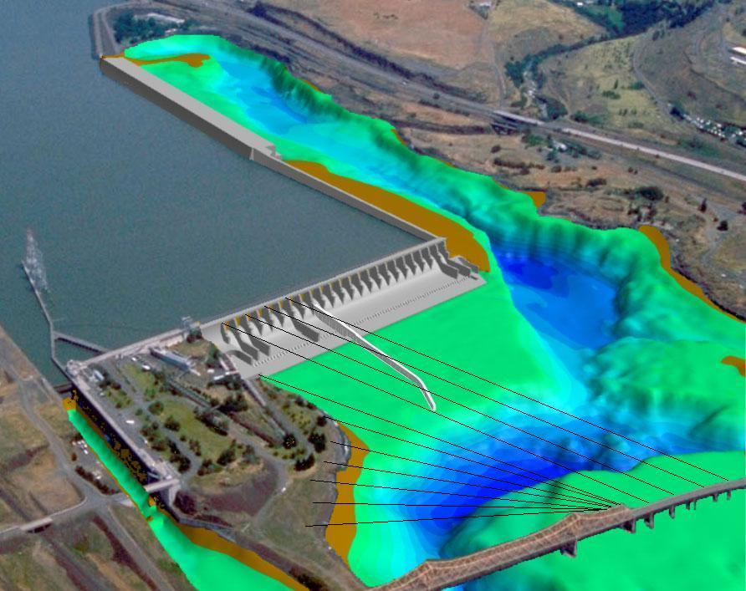
TDA 2010 Avian Array.

FPP Change Forms
☺☺☺☺☺☺☺☺☺☺☺☺☺☺☺☺☺☺☺☺☺☺☺☺☺☺☺☺☺☺☺☺☺☺☺
☺☺☺☺☺☺☺☺☺☺☺☺☺☺☺☺☺☺☺☺☺☺☺☺☺☺☺☺☺☺☺☺☺☺☺
Change Request Number: 10BON007
Date: 13 November 2009
Proposed by: NWP
Location of Change: Table BON-3
Proposed Change:

Table BON-3. Adult fish counting schedule.
Period | Counting Method
January 1 – March 31 | Video count 0400–2000 PST
April 1 – October 31 | Visual count 0500-2100 DST
November 1 - December 31 | Video count 0400–2000 PST
Reason for Change: Due to the changes in Daylight savings time, all visual counting will be during DST.
Comments from others:
NWW (Moody)- Why are we changing these? Are we changing PST to DST at different times. The contract has enough wording in it to cover this time change. If we make it consistent PST as in the contract then we already know to adjust for DST. I do not want any confusion on this in the future between the fish counting contract and the FPP. Keep it one reference of time PST. Do not change it.

BON Fisheries- Project Fisheries is fine with the changes.
Record of Final Action: Approved at December FPOM
☺☺☺☺☺☺☺☺☺☺☺☺☺☺☺☺☺☺☺☺☺☺☺☺☺☺☺☺☺☺☺☺☺☺☺
Change Request Number: 10TDA004
Date: 13 November 2009
Proposed by: NWP
Location of Change: Table TDA-1
Proposed Change:
Table TDA-1. Adult fish counting schedule at The Dalles Dam.
Period | Counting Method
April 1 – October 31 | Visual count 0500 - 2100 DST
Reason for Change: Due to the changes in Daylight savings time, all visual counting will be during DST.
Comments from others:
NWW (Moody)- Why are we changing these? Are we changing PST to DST at different times. The contract has enough wording in it to cover this time change. If we make it consistent PST as in the contract then we already know to adjust for DST. I do not want any confusion on this in the future between the fish counting contract and the FPP. Keep it one reference of time PST. Do not change it.

TDA Fisheries (Cordie)- Makes sense. I don't think fish change their clocks.
Record of Final Action: Approved at December FPOM.
☺☺☺☺☺☺☺☺☺☺☺☺☺☺☺☺☺☺☺☺☺☺☺☺☺☺☺☺☺☺☺☺☺☺☺
Change Request Number: 10JDA003
Date: 13 November 2009
Proposed by: NWP
Location of Change: Table JDA-3
Proposed Change:
Table JDA-3. Adult fish counting schedule.
Period | Counting Method
April 1 – October 31 | Visual count 0500 – 2100 DST
Reason for Change: Due to the changes in Daylight savings time, all visual counting will be during DST.
Comments from others:
NWW (Moody)- Why are we changing these? Are we changing PST to DST at different times. The contract has enough wording in it to cover this time change. If we make it consistent PST as in the contract then we already know to adjust for DST. I do not want any confusion on this in the future between the fish counting contract and the FPP. Keep it one reference of time PST. Do not change it.

Cordie- Makes sense. I don't think fish change their clocks.
Record of Final Action: Approved at December FPOM.
☺☺☺☺☺☺☺☺☺☺☺☺☺☺☺☺☺☺☺☺☺☺☺☺☺☺☺☺☺☺☺☺☺☺☺
Change Request Number: 10JDA004
Date: 13 November 2009
Proposed by: NWP
Location of Change: 2.5.1.2.d.2
Proposed Change: d. Powerhouse.
1. Operate entrances NE-1 and NE-2.
2. Operate four powerhouse floating orifices (1, 2, 18, and 19) and open associated auxiliary water diffusers. (See also 2.5.1.2.a.4.).
Reason for Change: Old information. Needs to be updated.
Comments from others:
Record of Final Action:
☺☺☺☺☺☺☺☺☺☺☺☺☺☺☺☺☺☺☺☺☺☺☺☺☺☺☺☺☺☺☺☺☺☺☺
Change Request Number: 10JDA004
Date: 13 November 2009
Proposed by: NWP
Location of Change: 2.5.1.2.d.2
Proposed Change:
d. Powerhouse.
1. Operate entrances NE-1 and NE-2.

2. Operate four powerhouse floating orifices (1, 2, 18, and 19) and open associated auxiliary water diffusers. (See also 2.5.1.2.a.4.).
Reason for Change: Old information. Needs to be updated.
Comments from others:
Record of Final Action:
☺☺☺☺☺☺☺☺☺☺☺☺☺☺☺☺☺☺☺☺☺☺☺☺☺☺☺☺☺☺☺☺☺☺☺
Change Request Number: 10MCN003
Date: October 6, 2009
Proposed by: CENWW -
Proposed Change: Change the following section of the 2010 Fish Passage Plan to reflect the delayed installation of the ESBS:
Section 2.3.1.2.b.1. Operate ESBSs with flow vanes attached to the screen. Installation of the ESBSs will not start before the first Monday of April and will be completed within the following two weeks.
Reason for Change: The 2008 Columbia Basin Fish Accords specify actions needed to be undertaken and considered to assist with Pacific Lamprey Passage. Item #3 under juvenile actions to be taken says the Corps shall, “consider lifting extended length screens (primarily at McNary but also at Columbia and Snake River dams) in consultation with the NOAA and the Tribes.”
The delay of ESBS installation is designed to benefit a pulse of lamprey that tend to migrate downstream just before a larger number of juvenile salmon and steelhead arrive at MCN around the 20th of April.
Comments from others: NWW, NOAA and CRITFC all provided handouts with fish numbers. Fredricks provided fish numbers and the estimated mortality related to not putting screens in. He mentioned that this may need to result in re-opening of the consultation for the incidental take. More information is needed before a decision could be made.
Record of Final Action:
☺☺☺☺☺☺☺☺☺☺☺☺☺☺☺☺☺☺☺☺☺☺☺☺☺☺☺☺☺☺☺☺☺☺☺
Change Request Number: 10MCN0005 Trash rack cleaning frequency
Date: November 4, 2009
Proposed by: NWW – Operations.
Proposed Change: MCN 2.3.1.2. Fish Passage Period (April 1 through December 15)
a. Forebay Area and Intakes.

- Remove debris from forebay and trashracks as required to minimize impacts on fish condition. Generally this will result in removing debris from trashracks at least four times per year - just prior to the fish passage season and, monthly for the first three months Additional raking may be required when heavy debris loads are present in the river. Fish quality and trash rack differential may also be an indicator of debris buildup on the trashracks. Project biologist shall determine when additional trash raking is required.

Reason for Change: This change was discussed and recommended at FFDRWG.
Comments from others: Wills asked how is was done before. Moody said it was done every other month and as needed. Kruger and Fredricks asked what would happen after the first three months. Klatte recommends taking out “additional”. Dykstra said that before, rakings may have occurred just a couple times a year. Kruger would like to know what will happen after the first three months and prior to the fish passage season. FPOM requests clarification. The first cleaning would be in March, then in April, May and June. Any additional rakings would occur as needed. Fredricks doesn’t see this as an aggressive way to deal with the trash at MCN. He would like to know how often they see problems after the spring.
Record of Final Action: Approved with changes. Dykstra to send the corrected form.
☺☺☺☺☺☺☺☺☺☺☺☺☺☺☺☺☺☺☺☺☺☺☺☺☺☺☺☺☺☺☺☺☺☺☺
Change Request Number: 10MCN0006
Date: November 4, 2009
Proposed by: John Bailey – NWW – Operations.
1.1.2. Juvenile Migration Timing. Juvenile migration timing at McNary Dam is indicated in Table MCN-1. The dates in the table are based on juvenile fish collection numbers and do not reflect FGE or spill passage. Salmon, steelhead, bull trout, lamprey, and other species are routinely counted. Maintenance of juvenile fish passage facilities that may impact juvenile fish passage or facility operations should be conducted during the winter maintenance season.
Table MCN-1. Juvenile migration timing at McNary Dam based on juvenile fish collection numbers.
% Collection | 2005 | 2006 | 2007 | 2008 | 2009
Yearling Chinook
10% | 5/3 | 4/21 | 5/2 | 4/9 | 5/3
90% | 5/29 | 5/19 | 5/26 | 5/27 | 5/25
Sub-yearling Chinook
10% | 6/16 | 6/12 | 6/23 | 6/22 | 6/18
90% | 7/3 | 7/19 | 7/29 | 8/9 | 7/22
Clipped Steelhead
10% | 4/19 | 4/23 | 4/30 | 5/3 | 4/27
90% | 5/29 | 5/23 | 5/24 | 5/23 | 5/21
Unclipped Steelhead
10% | 5/1 | 4/19 | 4/28 | 5/1 | 4/25
90% | 5/27 | 5/27 | 5/26 | 5/29 | 5/23
Sockeye
10% | 5/11 | 5/4 | 5/12 | 5/15 | 5/5
90% | 5/31 | 5/29 | 6/1 | 6/6 | 5/23
Reason for Change: Update table for 2010 Fish Passage Plan
Comments from others: need to add language that the numbers are for the last five years.
Record of Final Action: Approved, with changes, at December FPOM.
☺☺☺☺☺☺☺☺☺☺☺☺☺☺☺☺☺☺☺☺☺☺☺☺☺☺☺☺☺☺☺☺☺☺☺
Change Request Number: 10LMN0004
Date: November 4, 2009
Proposed by: John Bailey – NWW – Operations.

1.1.2. Juvenile Migration Timing. Juvenile migration timing at Lower Monumental Dam is indicated in Table LMN-1. The dates in the table are based on juvenile fish collection numbers and do not reflect FGE, RSW or spill passage. Salmon, steelhead, bull trout, lamprey, and other species are routinely counted. Maintenance of juvenile fish passage facilities that may impact juvenile fish passage or facility operations should be conducted during the winter maintenance season.
Table LMN-1. Juvenile migration timing at Lower Monumental Dam based on juvenile fish collection numbers.
% Collection | 2005 | 2006 | 2007 | 2008 | 2009
Clipped Yearling Chinook
10% | 4/19 | 5/2 | 5/12 | 5/18 | 5/10
90% | 5/17 | 5/19 | 5/20 | 5/25 | 5/25
Unclipped Yearling Chinook
10% | 4/16 | 4/29 | 5/12 | 5/18 | 5/10
90% | 5/19 | 5/24 | 5/22 | 6/2 | 6/1
Sub-yearling Chinook
10% | 6/2 | 5/26 | 5/30 | 6/5 | 6/2
90% | 6/30 | 7/2 | 7/8 | 7/5 | 7/3
Clipped Steelhead
10% | 4/20 | 4/29 | 5/12 | 5/18 | 5/10
90% | 5/20 | 5/22 | 5/21 | 5/28 | 6/1
Unclipped Steelhead
10% | 5/6 | 5/2 | 5/12 | 5/20 | 5/10
90% | 5/24 | 5/22 | 5/23 | 5/31 | 6/6
Clipped Sockeye
10% | 5/22 | 5/16 | 5/17 | 5/21 | 5/20
90% | 6/6 | 5/29 | 5/24 | 6/2 | 6/1
Unclipped Sockeye
10% | 4/28 | 5/4 | 5/12 | 5/22 | 5/10
90% | 6/1 | 5/31 | 6/5 | 6/7 | 6/4
Note: Migration timing calculations affected by later fish collection start dates (2006 through 2009).
Reason for Change: Update table for 2010 Fish Passage Plan
Comments from others: need to add language that the numbers are for the last five years.
Record of Final Action: Approved, with changes, at December FPOM.
☺☺☺☺☺☺☺☺☺☺☺☺☺☺☺☺☺☺☺☺☺☺☺☺☺☺☺☺☺☺☺☺☺☺☺
Change Request Number: 10LGS001
Date: October 26, 2010
Proposed by: Greg Moody
Proposed Change: Update operational language in the FPP describing the operation change from low crest to high crest surface spillbay weir.
Section 2.3.1.2. Fish Passage Period (April 1 through December 15)
g. Surface Spillbay Weir (SSW)
- Spring fish passage season will start with SSW-LO in place, even if river discharges are less than 75 kcfs.
- After the spring freshet has passed, the SSW-HI will be installed after river discharge falls below 75 kcfs for three days in a row and will remain in place for the rest of the season, even if river discharges subsequently increase above 75 kcfs. The trigger to change to high crest is further based on the following:
    - forecasts indicate continuing lower river discharges;
    - a review of the juvenile fish counts at Little Goose monitoring to prevent changes during the middle of peak outmigration;
    - coordinated with regional fish managers.
- The uniform spill pattern, with no SSW operating, will be used when river discharges are too low to maintain a 30% spill ratio with a SW operating,
or as an alternate pattern when the SW must be closed for any reason, such as when switching from SW-LO to SW-HI.
- When summer discharge falls below 35kcfs, and coordinated through CENWW-OD-T, the SSW will be removed from service within three regular workdays.

Reason for Change: First year of operation of the SSW at Little Goose had very basic information on the operation of the SSW in the footnotes to the spill tables. This brings the operating information from the footnotes into the main text of the FFP.

Comments from others:
Record of Final Action: Approved at December FPOM
☺☺☺☺☺☺☺☺☺☺☺☺☺☺☺☺☺☺☺☺☺☺☺☺☺☺☺☺☺☺☺☺☺☺☺
Change Request Number: 10LGS002
Date: November 4, 2009
Proposed by: John Bailey – NWW – Operations.
1.1.2 Juvenile Migration Timing. Timing dates affected by later collection start dates in 2006- 2008. Table LGS-1 shows passage timing at Little Goose Dam. Table LGS-1 dates are based on juvenile fish collection numbers only. Salmon, steelhead, bull trout, lamprey, and other species are counted. Maintenance of fish passage facilities that may impact juvenile passage or facility operation should be conducted during the winter maintenance season.
Table LGS-1. Juvenile migration timing at Little Goose Dam based on collections.
% Collection | 2005 | 2006 | 2007 | 2008 | 2009
Clipped Yearling Chinook
10% | 5/5 | 4/26 | 5/8 | 5/6 | 4/25
90% | 5/16 | 5/19 | 5/20 | 5/28 | 5/23
Unclipped Yearling Chinook
10% | 4/29 | 4/19 | 5/9 | 5/4 | 4/23
90% | 5/27 | 5/23 | 5/23 | 5/30 | 5/25
Sub-yearling Chinook
10% | 5/12 | 5/24 | 6/7 | 6.4 | 5/29
90% | 6/20 | 7/4 | 7/6 | 7/23 | 6/30
Clipped Steelhead
10% | 4/26 | 4/21 | 5/10 | 5/1 | 4/23
90% | 5/16 | 5/20 | 5/27 | 5/23 | 5/25
Unclipped Steelhead
10% | 4/27 | 4/20 | 5/10 | 5/8 | 4/24
90% | 5/20 | 5/20 | 5/30 | 6/1 | 5/29
Clipped Sockeye
10% | 5/21 | 5/16 | 5/16 | 5/21 | 5/20
90% | 6/4 | 5/29 | 5/30 | 6/6 | 5/31
Unclipped Sockeye
10% | 4/28 | 4/21 | 5/7 | 5/18 | 4/16
90% | 6/6 | 5/27 | 6/4 | 6/9 | 5/27
Reason for Change: Update table for 2010 Fish Passage Plan
Comments from others: need to add language that the numbers are for the last five years.
Record of Final Action: Approved, with changes, December FPOM.
☺☺☺☺☺☺☺☺☺☺☺☺☺☺☺☺☺☺☺☺☺☺☺☺☺☺☺☺☺☺☺☺☺☺☺
Change Request Number: 10APPB001
Date: November 4, 2009
Proposed by:John Bailey – NWW – Operations.
Proposed Change (underlined): Appendix B 3. Program Duration:
d. Emergency Notification Criteria: Project Biologists will report to the CENWW Transportation Coordinator when high water temperatures or other factors increase collection mortality to 6 percent of daily collection for 3 consecutive days or if daily collection mortality exceeds 10,000 fish. Mortality rates of 6% or greater do not need to be reported when 50 or fewer fish are reported in the daily collection. The Transportation Coordinator will evaluate the situation and shall notify NOAA Fisheries and may arrange a conference call, if needed, with TMT to discuss the options of continuing collection and transportation or to bypass fish. In the event of a fish loss exceeding conditions set forth in the ESA Section 10 Permit for the transportation program, the Corps shall notify NOAA Fisheries and reopen consultation as needed. If icing conditions threaten facility integrity or present unsafe conditions on the transport route, transport operations may be terminated early by the project’s Operations Manager. Emergency termination or modification of the transportation program will be coordinated by the CENWW Transportation Coordinator with NOAA Fisheries and TMT.

Reason for Change: During late summer collection and transport truck operations, daily fish collection numbers in most locations drop considerably. Lower Monumental and Little Goose facilities have at times recorded less than 10 fish per day in during daily collection over the course of 3 days. Incurring 1 fish mortality per day under this situation would produce a reportable 10% mortality rate which would be true but misleading as to the seriousness of the problem as only 3 mortalities would be involved. Requiring a minimum of 50 fish in the daily collection when reporting a 6% mortality rate will reduce the number of multiple reports on a very small number of fish mortalities. Most late summer mortalities are thought to be disease related during exposure to higher water temperature, not as a result of fish facility operations.

Comments from others: Issue discussed at the 06October 09 FPOM meeting under item 4.13 in the minutes. Fish Passage Plan Change form drafted at FPOM request for latter consideration. Tom Lorz (CRITFC) suggested there will be a lot of discussion about what minimum number is acceptable. Hevlin doesn’t like the 10,000 fish.
Record of Final Action: The added language has been approved but FPOM is still discussing the percentage and number of dead fish. Approved at December FPOM.
☺☺☺☺☺☺☺☺☺☺☺☺☺☺☺☺☺☺☺☺☺☺☺☺☺☺☺☺☺☺☺☺☺☺☺
Change Request Number: 10AppB002
Date: October 30, 2009
Proposed by: Tom Lorz (CRITFC) sent to Greg Moody (USACE)
Proposed Change: Add a section 4. Operating Criteria-(G)-6(new) under Appendix B Corps of Engineers Juvenile Fish Transportations Plan or it could be added to 3. Program Duration (D) of Appendix B.

Add language…”If a temperature gradient is observed in real time or predicted from temperature modeling at McNary from the forebay to the gatewells or the gatewells to the sampling/raceway facilities that exceeds 6 degree Fahrenheit, and/or collection mortality increases to 6 percent of daily collection for any 3 days in a rolling 5 day period or if daily collection mortality exceeds 10,000 fish, the project will immediately alter turbine operations to reduce mortality and temperature where possible. If turbine operations are already optimized for temperature then additional spill will be provided so long as the spill levels do not exceed the gas cap. Operations will be coordinated as soon as possible with FPOM/TMT but are not required prior to modifying operations.

Reason for Change: During the 2009 fish migration passage season the 6 percent mortality criteria mentioned above in section 3 – d of Appendix B of the FPP was triggered in August. It also corresponded to temperature differences in the facility that exceeded 6 degrees F and got as high as 11 degrees F. Spill was increased for several days to help reduce the number of fish using the bypass facility during these extreme temperature gradients as well as to try to reduce flow for areas of warm water to the powerhouse. Mortality did drop after the operations were started. It would be prudent to have language in the FPP to deal with such situations in advance then to have to wait for coordination and the discussion at a meeting between FPOM/TMT to begin altering operations that will likely reduce facility mortality.
Comments from others: FPOM is concerned about six percent mortality and 10,000 fish prior to notification. Assume the turbine actions will be done.
Record of Final Action: Lorz will re-write and re-submit.
☺☺☺☺☺☺☺☺☺☺☺☺☺☺☺☺☺☺☺☺☺☺☺☺☺☺☺☺☺☺☺☺☺☺☺
November 2009
Sunday | Monday | Tuesday | Wednesday | Thursday | Friday | Saturday
1  USACE FPP change forms due to Mackey and Baus | 2  ERDC- JDA internal  BON ITS dewater | 3  ERDC- JDA internal | 4  ERDC- JDA internal | 5  ERDC- JDA internal  TDA spillwall call  Project boundaries mtg- NOAA | 6  ERDC- JDA internal | 7  BON AFF orifice flow
8 | 9  BON AFF dewater | 10  Happy Birthday | 11  HOLIDAY  Veteran’s Day | 12 FPOM Meeting  1st Draft FPP out. | 13 | 14
15  Happy Birthday | 16  JDA-N dewater | 17 | 18  Lamprey workshop- Vanc, WA  Happy Birthday | 19  TDA spillwall call | 20 | 21
22 | 23 | 24  BON NDE lamprey mods mtg- NOAA  Happy Birthday | 25 | 26  Happy Thanksgiving | 27 | 28
29 | 30

December 2009
Sunday | Monday | Tuesday | Wednesday | Thursday | Friday | Saturday
 |  | 1  AFEP review  BON F1 OOS  BON UMT- OOS | 2  AFEP review  UMT array install  TDA-E dewater | 3  AFEP review  TDA spillwall call | 4  BON BI to orifice flow | 5
6 | 7  BON BI dewater | 8  FPOM- NOAA  AFF mtg- NOAA  BON diffuser pools | 9  SMP meeting | 10  SMP meeting | 11  Happy Hanukkah | 12
13 | 14.  ERDC- JDA/TDA | 15  ERDC- JDA/TDA  Adult fish counting ends LWG.  Fish screens pulled | 16  ERDC- JDA/TDA | 17  ERDC- JDA/TDA  TDA spillwall call | 18  ERDC- JDA/TDA | 19
20  Happy Birthday | 21  BON DSM2 dewater Regional FPP comments due to Mackey and Baus. | 22  BON BI exit survey | 23 | 24 | 25  HOLIDAY  Merry Christmas | 26  Happy Kwanzaa
27 | 28 | 29 | 30 | 31  TDA spillwall call

January 2010
Sunday | Monday | Tuesday | Wednesday | Thursday | Friday | Saturday
31 |  |  |  |  | 1  HOLIDAY  Happy New Year | 2
3 | 4 | 5 | 6 | 7  NWP FFDRWG- RDP | 8 | 9
10 | 11  JDA S. fish turbine ROV | 12  JDA-S dewater | 13  FPP meeting- NOAA  BON ROV inspect  BON BGS dive | 14  FPOM- NOAA  Final draft FPP out.  TDA spillwall call  BON ROV inspect  BON BGS dive | 15  BON BGS dive | 16
17 | 18  HOLIDAY  MLK Birthday | 19 | 20 | 21 | 22 | 23
24 | 25  JDA-S ent dewater | 26 | 27 | 28  TDA spillwall call | 29 | 30

Lower Granite: Kelt upgrades to existing JFF
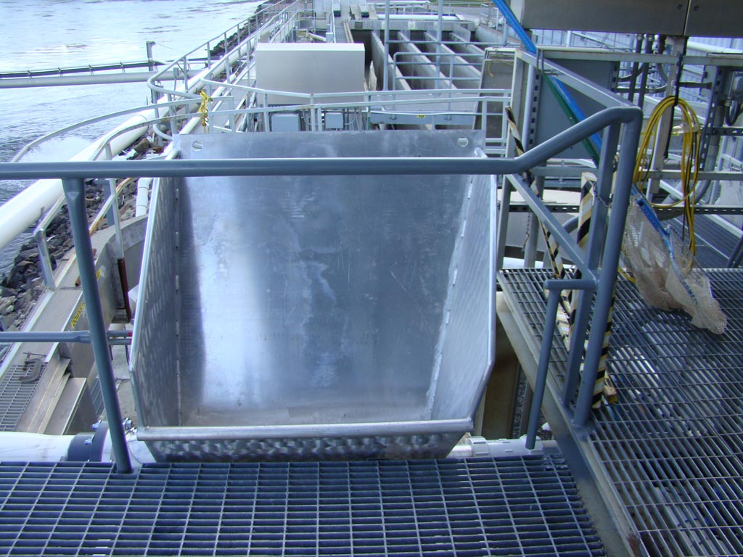
small bin used to route kelts from the separator into the pipe
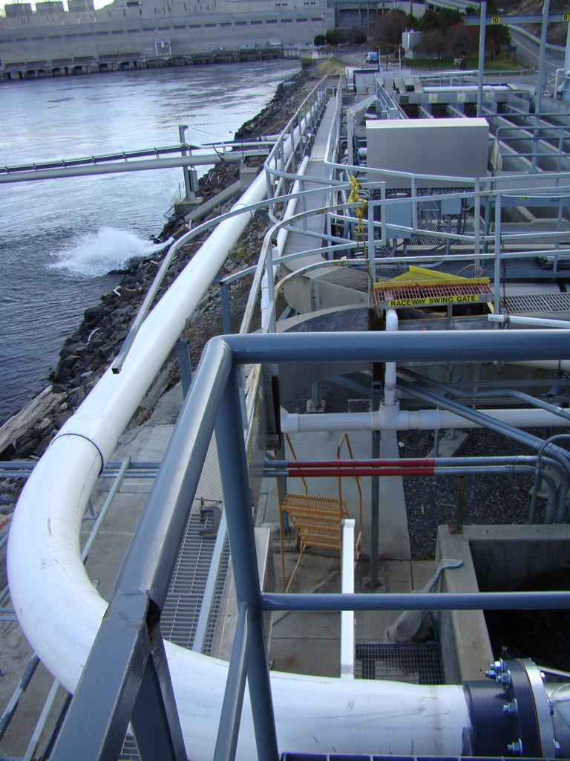
10-inch pipe from the routing bin to the holding tanks
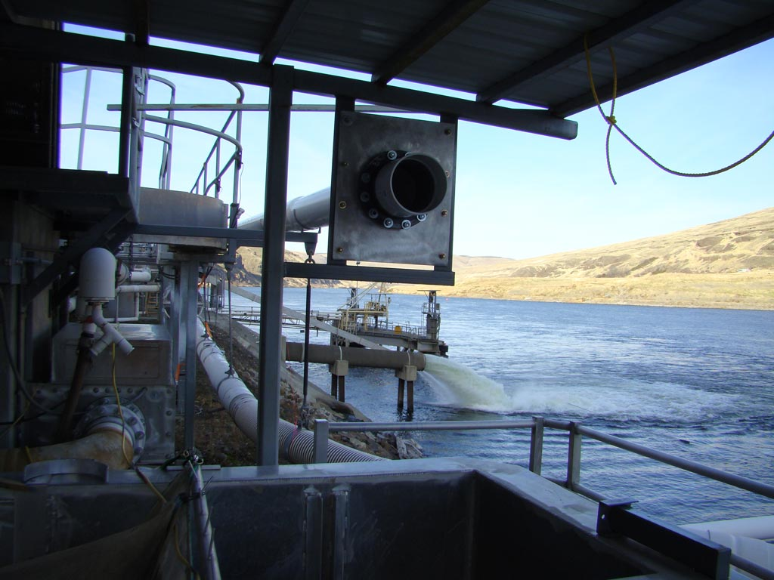
Present end of the kelt pipe. Will finish when tanks from UI arrive
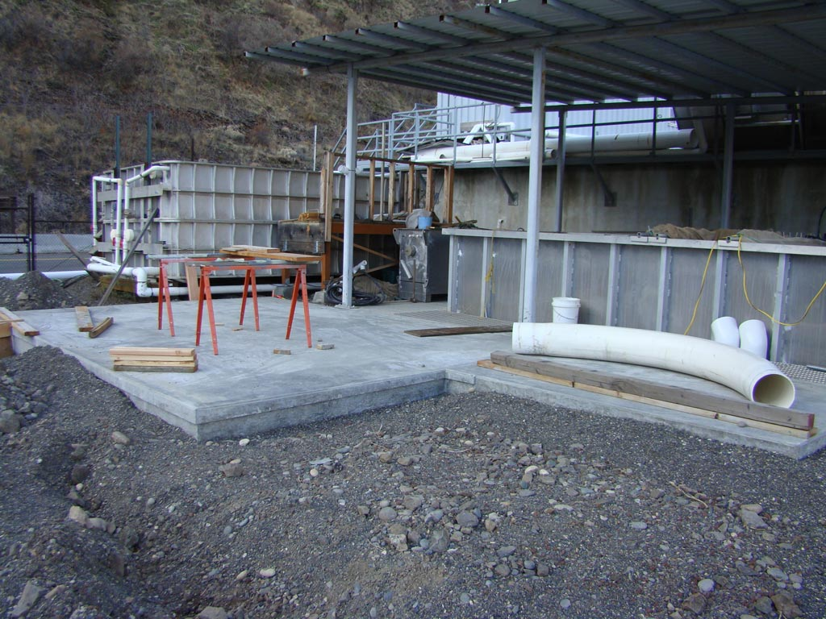
Concrete pads for the two kelt tanks
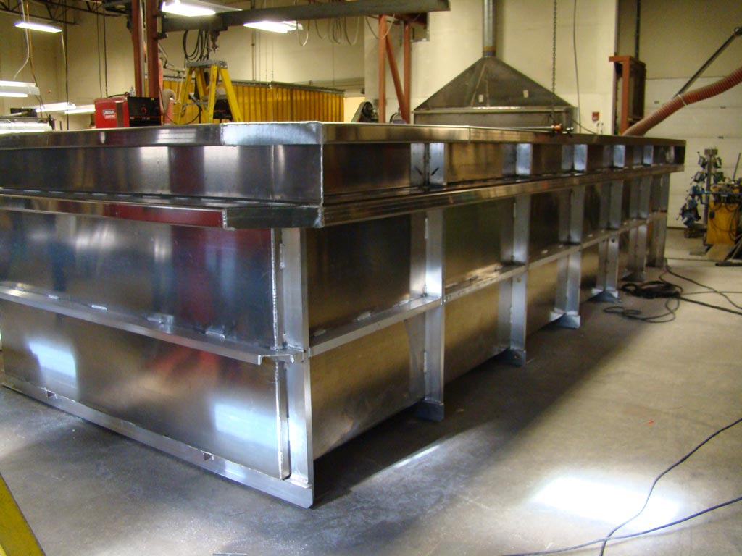
Kelt tank under construction at the UI

